“BEST BEFORE” DATE 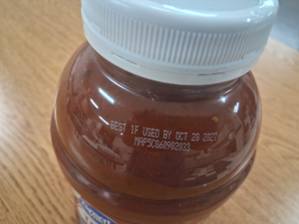
Indicates when a product will be of the best quality or flavor. It is not a purchase or safety date.

SIGNS OF FOOD SPOILAGE:
*Smells “off”
*Moldy
*Different Texture than it is supposed to be
*Unpleasant

ABOVE ALL:
WHEN IN DOUBT, THROW IT OUT!
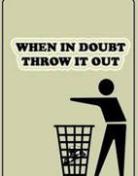

Resources:

You can obtain “Safe Food Storage – The Refrigerator and Freezer” and “Safe Food Storage- The Cupboard” from www.ksre.kstate.edu

**Flyer put together by Thursday Night Live FCE (Family and Community Education) Unit
Bourbon County
For more information contact the K-State Southwind Extension District at (620) 223-3720.
HOW ABOUT A DATE?

According to the FDA, Americans are throwing away about 1/3 of our food.
(20 pounds per person per month!)

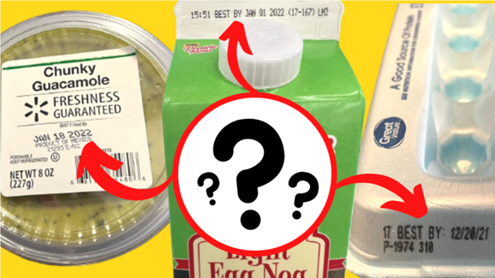

Uncertainty about the meaning of food dates causes us to waste about 20% of our food. There are a wide variety of phrases used, learn that you don’t have to necessarily need to throw out food because of a date.
“USE BY” DATE
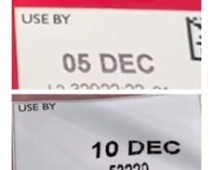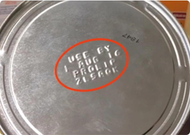

“USE BY” DATE

“Use-By” date is the last date for use of the product is while at peak quality. It is not a safe date except for when used on infant formula.

GUIDELINES FOR FRESHNESS:
*Eggs: go by “sell-by date, store 3-5 weeks in the back of refrigerator.
*Milk: 7 days. Store in the back of the refrigerator
*Ground meat/poultry: 1-2 days
*Cooked meat/poultry: 3-4 days
*Steaks: 3-5 days
*Lunch meat: 2 weeks unopened, 3-5 days opened
*Dry pasta: 1-2 years
*Canned fruit: 12-18 months, or 5-7 days after opening
*Rice and dried beans: 2 years, or 3-4 days in the refrigerator after cooking.

Special exception pertaining to infant formula:
Federal regulations require a “Use-By” date on the product of infant formula. Consumption by this date ensures the formula contains no less than the quality of each nutrient described on the label. The
Formula must maintain an acceptable quality to pass through an ordinary bottle nipple. Do not buy or use baby formula after its “Use Buy” date.

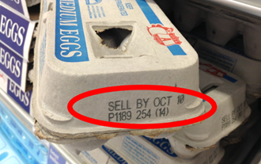

“SELL BY” DATE

Lets the store know how long to display the product for sale for inventory management.

SPECIAL TIPS:

*Keep your refrigerator below 40 degrees F. and use airtight containers.
*Use the “first in, first out” method to rotate pantry goods.
*Freeze meat, cheese, and bread near the “sell by” date.
*Don’t’ fear “best by” date. It’s about quality, not safety
*Trust your nose, mouth, eyes, and your brain to tell you if food is bad.

