The Regular Council Meeting on April 11, 2023 at Uniontown City Hall, was called to order at 7:05PM by Mayor Jurgensen. Council members present were Jess Ervin, Danea Esslinger, Josh Hartman, Amber Kelly, and Brad Stewart. Also in attendance for all or part of the meeting were Don George (KDWPT), Norman Bockover, Mary Pemberton, Betsie Binford, City Superintendent Bobby Rich, City Treasurer Charlene Bolinger, and City Clerk Sally Johnson.
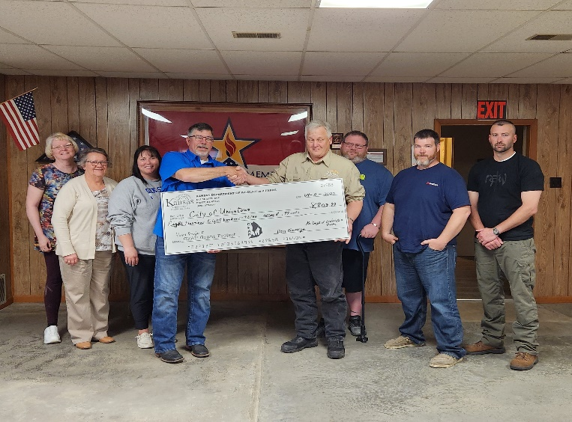
SPECIAL CONSIDERATIONS/PROJECTS
Don George, Kansas Department of Wildlife, Parks and Tourism presented the grant reimbursement check to Council for the completion of the Uniontown School Pond Improvement Project and encouraged the council to apply for phase II. He complimented Clerk’s paperwork for the grant. He would like application for phase II completed by the May meeting. Mayor Jurgensen will touch base with county regarding rock and hauling.

Motion by Ervin, Second by Esslinger, Approved 5-0 to submit an application for 2023 CFAP Grant for Phase II of Uniontown School Pond Improvement Project

CITIZENS REQUEST
Norman Bockover asked about citywide trash service. The Council rescinded Ordinance 199 at the April 6, 2023 Special Meeting and will no longer be pursuing this.

Betsie Binford, Old Settlers’ Committee, requested permission for a street dance as part of this year’s celebration. Council said NO ALCOHOL ALLOWED and asked Clerk Johnson to check with our insurance agent on whether our liability insurance would cover or if the Committee will need an event policy.

Motion by Hartman, Second by Kelly, Approved 5-0 to allow Old Settlers’ Committee to sponsor a street dance for this year’s celebration with no alcohol allowed

Mary Pemberton presented a copy of the proposed mural for the Rural Murals and Public Art Grant.

Mayor Jurgensen informed that the Dale Jackson Memorial Fire Truck for the park should be installed soon.

FINANCIAL REPORT
Treasurer Bolinger present the March 2023 Treasurer’s Report. Beginning Checking Account Balance for all funds was $349,967.37, Receipts $52,804.09, Transfers Out $4,666.00, Expenditures $52,703.68, Checking Account Closing Balance $345,40178. Bank Statement Balance $367,965.70, including Checking Account Interest of $78.70, Outstanding Deposits $64.32, Outstanding Checks $22,628.24, Reconciled Balance $345,401.78. Water Utilities Certificates of Deposit $33,223.90, Sewer Utilities Certificate of Deposit $19,841.76, Gas Utilities Certificates of Deposit $33,499.83, Total All Funds, including Certificates of Deposit $431,967.27. Year-to-Date Interest in Checking Acct is $227.98, and Utility CDs $164.51 for a Total Year-to-Date Interest of $392.49. Also included the status of the Projects Checking Account for the month of March 2023, Beginning Balance $0, Receipts $0, Expenditures $0, Ending Balance $0. March Transfers from Sewer Utility Fund to Sewer Revolving Loan $1,402.00, to Lease Purchase-Maint Vehicle $410.00; from Water Utility Fund to GO Water Bond & Interest $1,624.00, to Lease Purchase-Maint Vehicle $410.00; from Gas Utility Fund to Lease Purchase-Maint Vehicle $410.00; from General Fund to Lease Purchase-Maint Vehicle $410.00; for Total Transfers of $4,666.00. Net Loss for the month of March $4,565.59, Year-to-Date Net Income $1,849.81. Budget vs Actual Gas Fund YTD Revenue $58,162.08 (37.1%), Expenditures $39,937.71 (17.7%); Sewer Fund YTD Revenue $9,124.88 (24.8%), Expenditures $8,077.26 (19.6%); Water Fund YTD Revenue $29,938.79 (24.5%), Expenditures $28,626.06 (17.9%); General Fund YTD Revenue $56,480.34 (37.7%), Expenditures $51,280.83 (27.7%); and Special Highway YTD Revenue $2,093.98 (28.1%), Expenditures $0 (0%). The April 2023 estimated payables in the amount of $20,298.04 were presented.

CONSENT AGENDA
Motion by Esslinger, Second by Ervin, Approved 5-0, to approve Consent Agenda:
- Minutes of March 14, 2023 Regular Council Meeting and April 6, 2023 Special Council Meeting
- Treasurer’s Report, Monthly Transaction Report & Accounts Payables

DEPARTMENT REPORTS
City Superintendent Rich asked what is to be done about the rock post that has fallen in the southeast corner of the park. After discussion of methods to repair, it was decided to put rock in the shop until a method is decided upon.

Codes Enforcement Officer Coyan was absent. He did submit a letter and it was included in the April newsletter. Citywide cleanup is scheduled for May 1-4. Clerk Johnson reported that someone came in this morning to report that one of the dogs at 108 Second St had her granddaughter trapped in the post office growling at her. Johnson called the dog owner and asked him to please keep his dogs on his property or under his control at all times. He said he is planning to put a kennel in the backyard, but no timeline given.

Clerk Johnson informed the council a letter of resignation was received from Ginger Ervin for her custodian/water sampler position.
The Municipal Services 2023 Budget Workshop dates were discussed.

Motion by Ervin, Second by Stewart, Approved 5-0 to allow Sally Johnson to attend one of the webinar and Charlene Bolinger to attend the May 25 in person session at Iola, cost of workshop $75/person

She had previously sent CDBG grant information to council. After discussion, it was decided there is not enough time to get a preliminary engineering report or application submitted by May 1.

COUNCIL REPORT
Councilman Ervin – nothing
Councilwoman Esslinger – nothing
Councilman Hartman – nothing
Councilwoman Kelly – nothing
Councilman Stewart – nothing
Mayor Jurgensen – A thank you note for the dish planter was received from Sally Johnson on the death of her father.
He would like to extend the culvert at Chaffin and the alley west of Franklin to accommodate trash trucks and school bus. He has a culvert but would like for the city to provide the rock.

Motion by Ervin, Second by Esslinger, Approved 5-0 to provide rock for the culvert extension at Chaffin and the alley west of Franklin

He also found someone to haul off the big rock at the railroad right-of-way and north of the pond.

OLD BUSINESS
Placemaking Project – Clerk Johnson has a zoom meeting with Jody and Rachel, HBCAT, on April 18. Mayor Jurgensen still trying to find time to convene committee.

American Rescue Plan Act update –The remaining $21,153.82 was discussed. It can be used for streets, repairs to the warehouse, a skid steer, or any type of governmental service. Clerk Johnson requested a new quote for materials to reskin and replace/add roll up doors for the warehouse. It was decided to use it for the warehouse. Clerk Johnson attended a webinar last week on submitting this year’s project and expenditure report which is due by April 30.

KMGA/MMGA Prepay project – documentation was mailed to KMGA on March 28.

Street repairs/resurfacing – Council directed Clerk Johnson to send out invitation for bids exactly like last year.

NEW BUSINESS

Motion by Ervin, Second by Hartman, Approved 5-0 to enter into executive session pursuant to nonelected personnel matters exception KSA 4319(b)(1), in order to discuss individual nonelected personnel positions and pay rates with the open meeting to resume at 8:41PM
Motion by Ervin, Second by Hartman, Approved 5-0 to extend executive session pursuant to nonelected personnel matters exception KSA 4319(b)(1), in order to continue discussion of individual nonelected personnel positions and pay rates with the open meeting to resume at 8:52PM
Open meeting resumed at 8:52.

Motion by Hartman, Second by Kelly, Approved 5-0 to allow Mayor to seek custodial/water sampler person and increase pay rate to $12/hour

Moved by Ervin, Second by Hartman, Approved 5-0, to adjourn at 8:53PM

