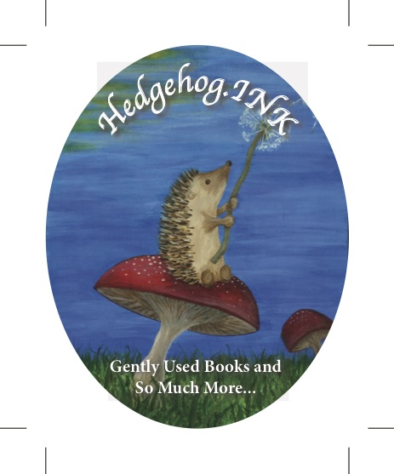
Hedgehog.INK!
Gently Used Books and So Much More…

Poetry Contest – April 2022 Entry Form

Name: ____________________________________________ Date: ______________

Check age group: _____Under 12 _____13-20 _____ Adult 21-55 _____ Seniors 55+
Address: __________________________________________________________________
Phone: ____________________ Email: _________________________________
Title of each Poem: (Remember, each poem needs to be on a separate page. Limit 2 poems per entry. – list titles here)

Entry: $5 entry fee. An entry may include up to 2 poems. One entry per person. Entry forms are available at the store or email Jan at hedgesbookstore@gmail.com for an entry form.

Deadline: All entries must be delivered, emailed to hedgesbookstore@gmail.com or mailed to Hedgehog.INK! 16 S. Main, Fort Scott, KS 66701 by 5:00 p.m. on April 30, 2022.

Theme: The theme for this year’s contest is, “What inspires you?”

Guidelines:
- Entries need to be typewritten if at all possible. (Neat hand-written manuscripts will be accepted.)
- Each poem should include a title and be submitted on a separate page. No other information should be included. A number will be assigned to each participant at the time of submission.
- Remember, do not include your name on your submitted poem.

Two winners in each age group will be posted during the first week of May. A celebration of poetry will be held at a later date.

620-670-2752 16 S. Main Fort Scott, KS 66701 hedgesbookstore@gmail.com A Community of Books for the Community

